Aeolus Android App Documentation

Architecture of the App
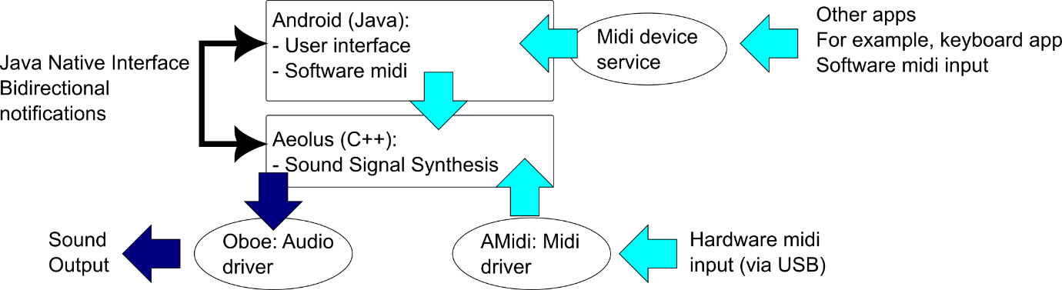
Figure 1. App architecture with midi and audio information flow

The global architecture of the Aeolus Android app is shown in Figure 1. The Aeolus Android app:
- Has a bipartite Android – Native architecture with the user interface and basic configurations in Android Java, and the Aeolus synthesizer implemented in C++
- The Aeolus code itself is adapted from https://github.com/SimulPiscator/aeolus
- Intercommunication between the two parts is through the Java Native Interface (JNI).
- The app is dependent on midi input, either via software midi (also known as virtual midi port), implemented by making use of Android’s “Midi Device Service”, or from midi hardware (via USB and Android’s Amidi library).
- The app uses Oboe for Audio output.

All novel code and most of the libraries used are under a GPL v3.0. Some Android code is under an Apache license compatible with GPL v3.0.

Android User interface
As usual for Android apps, the app presents itself as a collection of activities.

AeolusActivity
This is the main activity of the application. It is driven by the Java class AeolusActivity, which is also the main entry point of the application. Various xml layout files and Java classes are involved in constructing and managing this user interface.
  - How this user interface is constructed
The main user interface is built semi-automatically to reflect the Aeolus structure, which is defined in the text file “definition” (path: app/src/main/res/raw/aeolus.zip, the file “definition” is part of this zip). The contents of this text file are read by the native Aeolus implementation, and Java Android part driven by AeolusActivity queries this information via jni call to the C++ (Aeolus) part of the application. Based on the information received, the AeolusActivity and associated classes reconstitute the interface to reflect the number of divisions, the number of stops in each division, and other variable (tremulant) and constant elements (division on / off buttons) per division.
  - xml files
Figure 1 outlines the parts of the interface that are governed by individual xml files (in app/src/main/res/layout). The overall layout is by activity_aeolus.xml, while at various place, individual sub-layout xml are loaded, some of them multiple times for repeating similar elements.
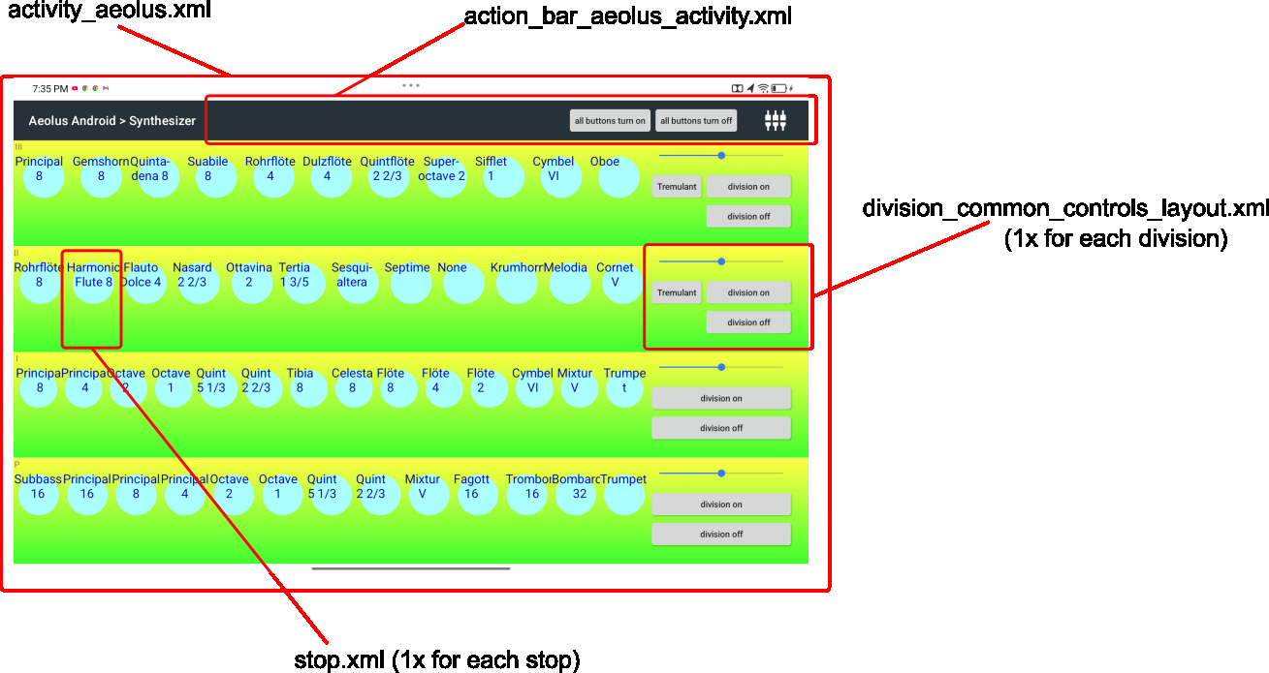
Figure 2. Use of xml layout files in the AeolusActivity interface
  - Java class files

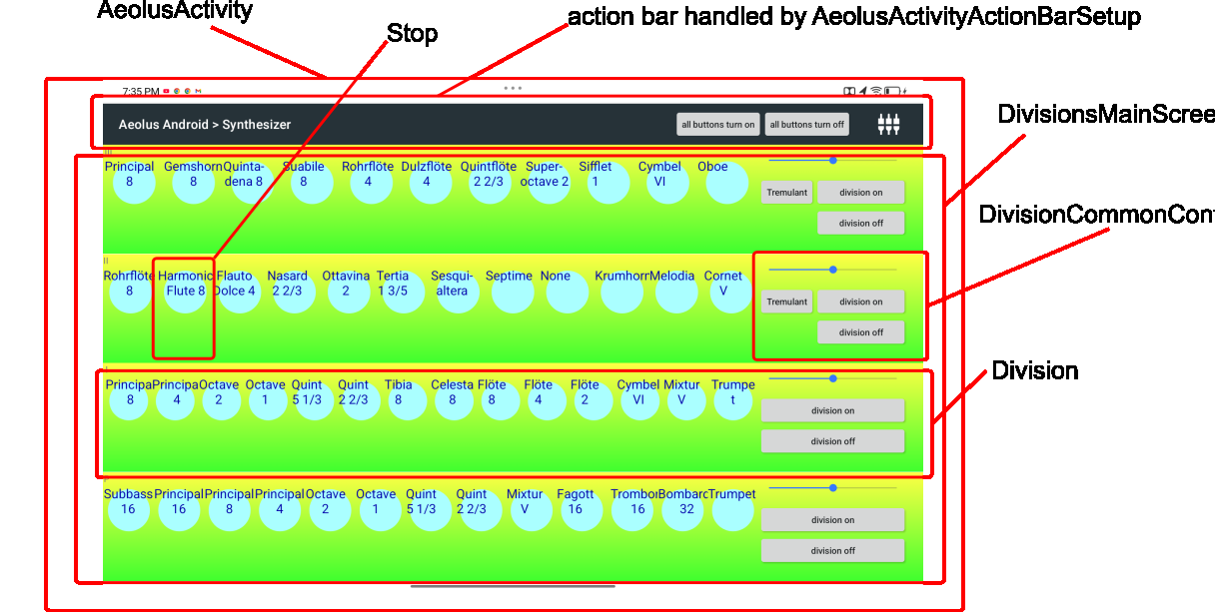
Figure 3. Java classes associated with the various User Interface elements
Figure 2 shows the java classes associated with the user interface. In practice, the graphical hierarchy is reflected by a corresponding object ownership hierarchy:
- The AeolusActivity class is instantiated by Android during application launch. This AeolusActivity object further holds:
- An object of type AeolusActivityActionBarSetup for configuration of the action bar (field theActionBar), which is among others responsible for loading action_bar_aeolus_activity.xml.
- This AeolusActivity object holds a DivisionsMainscreen object as its field theDivisionMainScreen. This object holds:
- An array of Division object (field divisions). The number of divisions is queried from the Aeolus C implementation, by default, there are 4 divisions. Each array member of divisions holds:
- A DivisionCommonControls object (field commonControls). The commonControls object is, among other things, responsible, for each division, to load division_common_controls_layout.xml.
- An array of Stop objects (field stops). Each stop objects loads its layout from stop.xml

AudioSettingsActivity
The Audio Settings Activity is a secondary activity of the app. It can be reached from the main AeolusActivity by clicking the settings button at the top-right of the screen. The aim of the audio settings activity is to allow for configuration of main audio and midi settings.
  - How this user interface is constructed
The layout of this user interface is for the most part fixed and corresponds to classical construction from different layout xmls.
The layout of the midi input mapping section is driven by data from the Aeolus native (C++) implementation. The midi mapping indicates the mapping of the input midi channels to the divisions. This is constructed dynamically by querying the number of divisions, midi channels and also the individual midi channel on/off settings from the Aeolus native part, followed by instantiation of the corresponding layout elements.
  - xml files
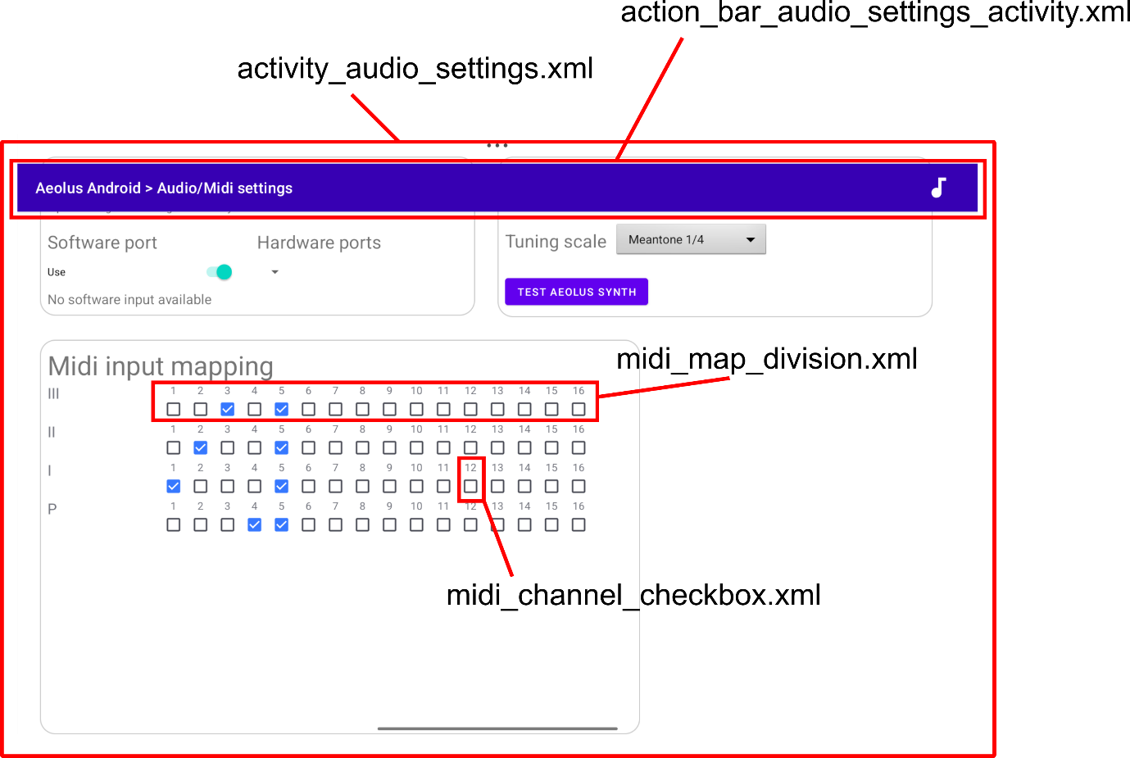
Figure 4 Use of xml layout files in the AudioSettingsActivity activity.
Figure 4 outlines the parts of the interface that are governed by individual xml files (in app/src/main/res/layout). The overall layout is by activity_audio_settings.xml, while at various place, individual sub-layout xml are loaded, some of them multiple times for repeating similar elements.
  - Java class files
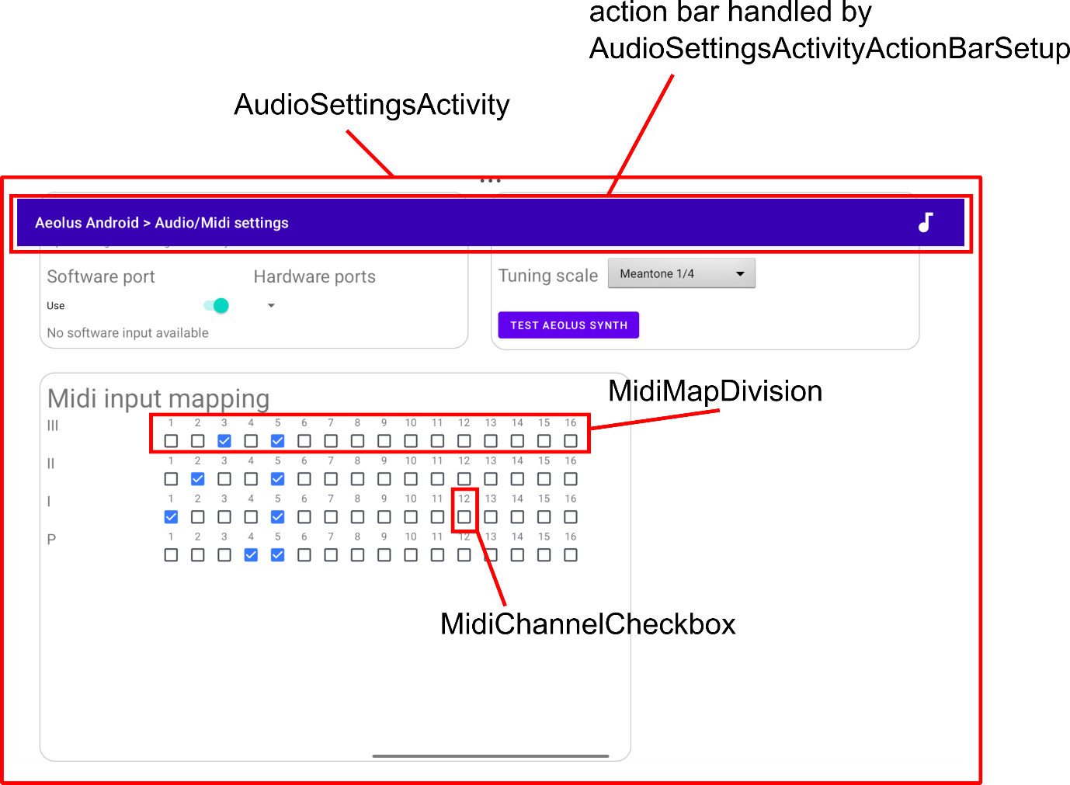
Figure 5 Java classes for the AudioSettingsActivity user interface

Figure 5 shows the java classes associated with the Audio Settings user interface. In practice, the graphical hierarchy is reflected by a corresponding object ownership hierarchy:
- The AudioSettingsActivity class is instantiated by Android during launch of the activity (typically, by user request from AeolusActivity). This AudioSettingsActivity object further holds:
- An object of type AudioSettingsActivityActionBarSetup for configuration of the action bar (field theActionBar), which is among others responsible for loading action_bar_audio_settings_activity.xml.
- This AudioSettingsActivity object also holds:
- An array of MidiMapDivision objects (field midiMapDivisions). The number of divisions is queried from the Aeolus C implementation, by default, there are 4 divisions. Each array member of midiMapDivisions holds:
- An array of MidiChannelCheckbox objects (field channelCheckboxes). Each MidiChannelCheckbox objects loads its layout from midi_channel_checkbox.xml

Event Flow and Calling Pattern

From Android Java to Aeolus C++
In this section, the flow of events, as well as requests for information, from Android Java to the native C++ implementation of Aeolus is described.
Note that initialization of the hardware midi via the Amidi library also needs collaboration between the Java and C part. This is documented as a separate topic below.

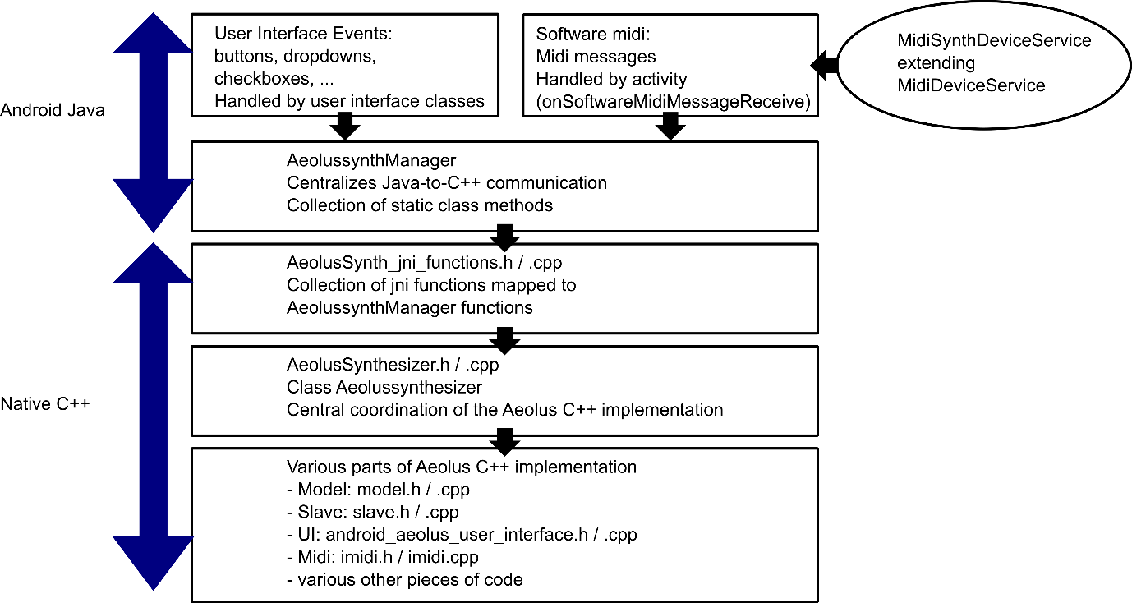
Figure 6. Event and calling flow from the Android Java to the native C++ Aeolus implementation
There are three central elements in the specific workflow from Android Java to the native Aeolus implementation:
- On the Java side, the AeolussynthManager class centralizes function calls to the native part. This means that the user interface events (c.f. previous section) and software midi events that initiate transmission or request of information to (respectively from) the native part need to call corresponding methods in AeolussynthManager. AeolussynthManager is designed as an entirely static class and is available as such from everywhere without instantiation.
- On the native C++ side, the central entry point is the AeolusSynth_jni_functions code, in the form of a .h and a .cpp file. This is a procedural library where static functions of AeolussynthManager are mapped to specific C functions. This happens through the usual conventions and formalism of the Java Native Interface (JNI).
- The Aeolus implementation in C++ is object-oriented, and the procedural jni functions in AeolusSynth_jni_functions refer to the central “synth” object of class AeolussynthManager for the accomplishment of the specific task. The AeolussynthManager object calls a wide variety of code in order to achieve the specific tasks.
Note that this is the function call flow. Since functions can both transmit arguments and return values, the information flow is bidirectional. The key feature in this section is that the chain of calls is initiated on the Java side.

From Aeolus C++ to Android Java
In this section, the flow of events, from the native part (C++) to Android Java is described.
Note that the information flow related hardware midi is treated separately below.
Aeolus C++ to Java notifications in the present implementation are the exception, the usual pathway of communication is initiated by the Android Java part since it constitutes the user interface where events are generated (previous section). There are however cases where notification from the Aeolus native part to Android Java is necessary. They are related to completion of tasks which take some time, and tasks where timing is unknown in advance:
- Completition of initial loading. The user interface can only be shown in full detail once the Aeolus synthesizer structure in terms of divisions and stops is known. Hence, completion of user interface display follows notification of complete loading (i.e. onLoadComplete event, in AeolusUIManager, see below).
- A second task requiring some time is the retuning of the pipes to a new base frequency or tuning ladder (onRetuned event in AeolusUIManager)
- Finally, since stops can in principle be updated through special midi commands, there is an implementation of onStopsUpdated in AeolusUIManager.

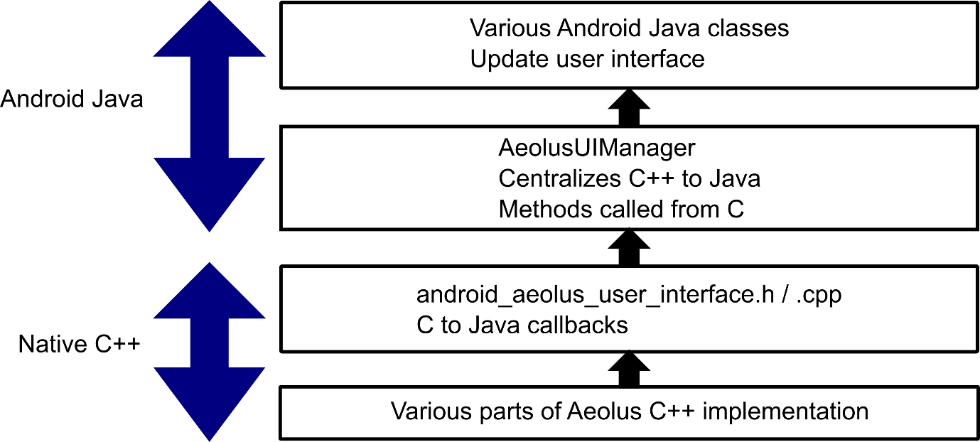
Figure 7. Flow of notifications from Aeolus C++ to Java. As outlined in the text, this is the exception rather than the norm, the usual calling flow is from Java to Aeolus C++, as shown in Figure 6.
The two main elements in the C++ to Java notification flow are:
- On the native C++ side, C++ to Java notifications are initiated by dedicated functions in the android_aeolus_user_interface code (.h and .cpp file). Note that C++ to Java calls are more complicated that Java to C++ calls because of the necessity of detailed callback objects, this is achieved through the initNative function and intermediate storage of callback method and class jni pointers.
- On the Java side, the AeolusUIManager implements the java callback methods .The callback functions are regular Java class member functions, with the particularity that they can also be invoked from the Android C++ part (i.e., here from to android_aeolus_user_interface.cpp with the aid of the method and class jni pointers stored during the initialization (initNative, see above).
These calls are notifications, and as a general rule trigger queries from Java to C++ as per the previous section.

Midi input handling

Hardware midi
One of the input modes for the Aeolus Android app is to receive midi messages from a USB midi device (c.f. Figure 1). For receiving hardware midi messages via USB, Aeolus Android uses the Amidi library. The working of the library is well explained at https://developer.android.com/ndk/guides/audio/midi

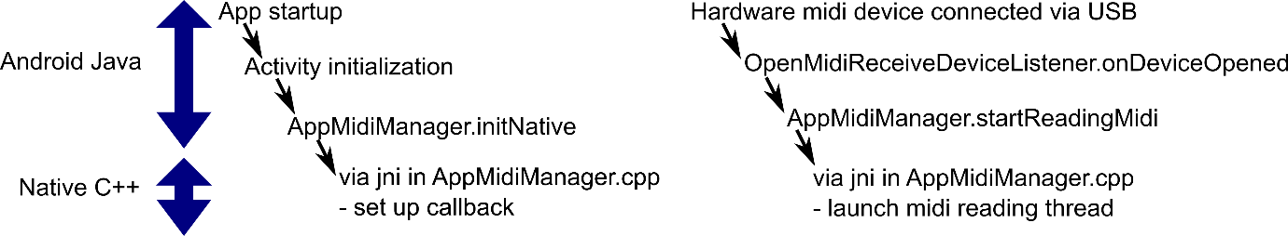
Figure 8. Setting up hardware midi input polling
Setting up and using Amidi follows this guide and concretely involves the following elements (Figure 8):
- Set up for callback. This is initiated from the java side at app startup and to set up a callback for later transmission of midi messages from the native part back to Java. The callback mechanism is set up via a call to:
- AppMidiManager.initNative on the Java side, and the corresponding native jni function in AppMidiManager.cpp: This sets up the possibility for callback to Java, to be used to transmit hardware midi messages received in the native part back to the Android app.
- Starting midi polling. This is also initiated from the Java side, specifically when a USB midi device is connected:
- The connection triggers a call to onDeviceOpened in the OpenMidiReceiveListener in AppMidiManager.java.
- AppMidiManager.startReadingMidi is called with the appropriate device information. Via jni, this invokes the corresponding jni function AppMidiManager.cpp. In this way, information about the chosen actual midi device from which midi messages should be read is transmitted to the native part.
- Midi message reading loop. The readThreadRoutine in AppMidiManager.cpp is called in the jni equivalent of the AppMidiManager.startReadingMidi method (i.e. Java_com_mathis_midiSynth_hardwareMidi_support_AppMidiManager_startReadingMidi). This launches a new thread executing the midi message reading loop.
Once the midi message reading loop is running, the messages are handled as shown in Figure 9:
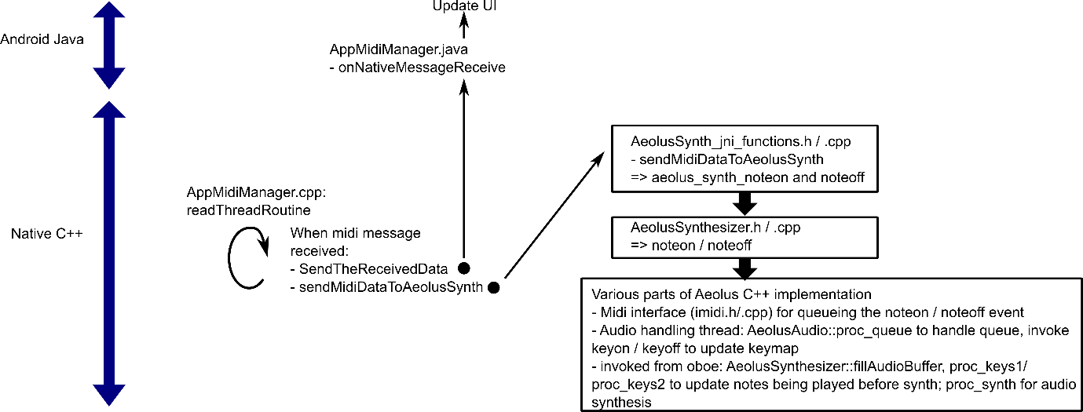
Figure 9. Hardware midi message handling
- Midi message handling. When midi messages are received in the midi message reading loop:
- The Aeolus synthesizer is notified, via sendMidiDataToAeolusSynth. sendMidiDataToAeolusSynth is implemented in AeolusSynth_jni_functions. This permits to integrate the general calling workflow for invoking Aeolus functions shown in Figure 6, with the aim to play the incoming midi messages using the Aeolus synthesizer to produce a corresponding audio signal. Some details of the specific midi handling sequence, internal to Aeolus, are shown in Figure 9.
- The Java Android part is notified via callback the SendTheReceivedData in AppMidiManager.cpp. This causes a callback to Java Android, invoking the AppMidiManager.onNativeMessageReceive method in Java. From there on, necessary updates in the user interface, as appropriate for the different activities, can take place. This permits the Android Java application to be aware of incoming hardware midi messages.

Software midi
Software midi, also known as virtual midi port, permits exchange of midi messages between apps. The Aeolus Android app opens a software midi port to accept midi messages produced by other other apps. Typically, the Aeolus Android app can be used with an external virtual midi keyboard to be played on the tablet.
The usage of software midi is described at https://developer.android.com/reference/android/media/midi/package-summary , section “Creating a MIDI Virtual Device Service”. Further technical details are provided below.

Software midi service declaration
Opening a software midi port is considered an explicit service of an Android app, and the following service declaration elements are needed:
- In the app’s AndroidManfest.xml file: Feature request via a <uses-feature> tag, and service declaration via <service> tag. See source code for the actual implementation and https://developer.android.com/reference/android/media/midi/package-summary for comprehensive information. The <service> tag defines among others the entry class for the software midi service, which here is the MidiSynthDeviceService class.
- A service declaration xml: res/xml/synth_device_info.xml. See source for the actual implementation and https://developer.android.com/reference/android/media/midi/package-summary for comprehensive information

Software midi initialization
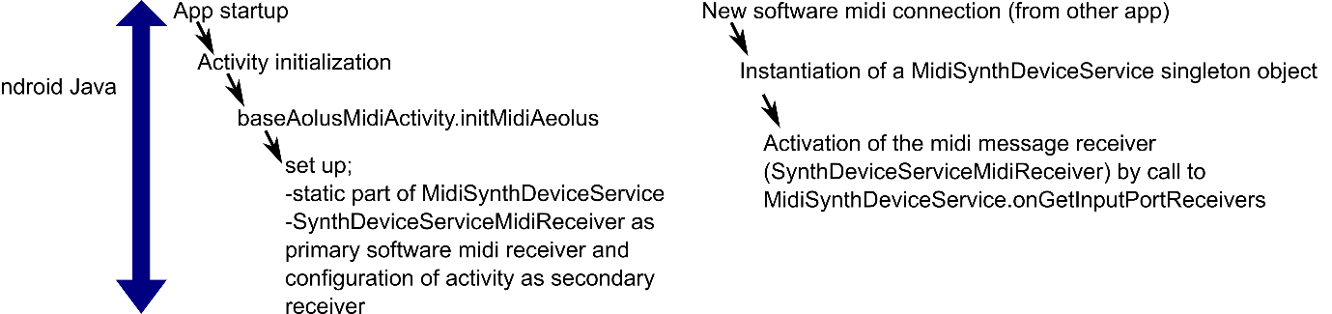
Figure 10 Setting up the software midi response chain
The entry point for the software midi initialization is the MidiSynthDeviceService class. The initialization involves two different phases:
- The first phase concerns static class initialization for the MidiSynthDeviceService class. It takes place upon app startup up, during the onCreate method of the Activity, and more particularly in the initMidiAeolus method defined by the base class baseMidiActivity. In this phase, static class variables of the MidiSynthDeviceService class are defined. In particular, during this phase, a static SynthDeviceServiceMidiReceiver object is associated with the MidiSynthDeviceService as the primary midi message reception responder, and the current Activity is defined as the secondary responder to which the SynthDeviceServiceMidiReceiver will transmit the incoming midi message.
- The second phase is triggered dynamically upon connection of an external source of software midi, typically a virtual keyboard app run on the same tablet. In this phase, instantiation of the MidiSynthDeviceService class is performed by Android; the choice of MidiSynthDeviceService as the MidiDeviceService class is determined by the android:name in the <service> tag in the App’s Android Manifest file. This field explicitly contains the MidiSynthDeviceService class as the target of the service. During object creation, the object created is created by Android but also retained as private static class singleton. MidiSynthDeviceService.onGetInputPortReceivers is then invoked and permits establishment of the routing of midi messages to the SynthDeviceServiceMidiReceiver object.

Software midi message handling
.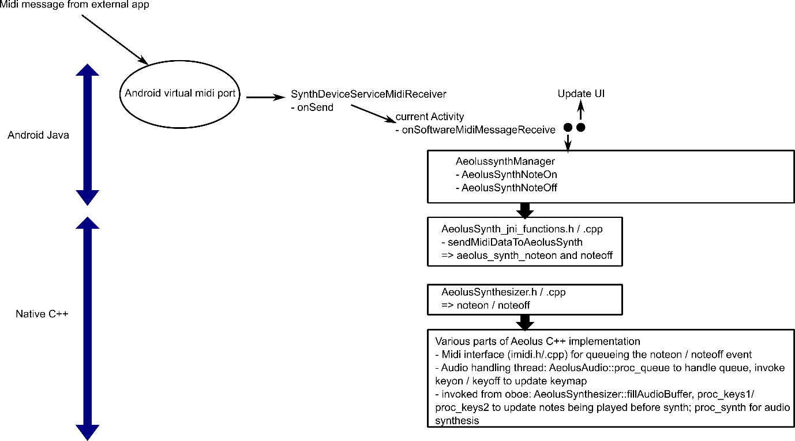
Figure 11 Software midi message handling
With the software midi setup in place as described in the previous sections, the Aeolus Android app is configured to handle incoming software midi messages.
The message flow is shown in Figure 11:
- Incoming midi messages are handled by the android virtual midi port service (built-in in Android). Following the initialization sequence described above, the SynthDeviceServiceReceiver is notified via a call to its “onSend” method. Note that this denomination is imposed by Android, it is “onSend” from the point of view of the midi sender, from the point of view of the Aeolus Android app, onReceive would sound more appropriate.
- The SynthDeviceServiceMidiReceiver is configured to invoke the onSoftwareMidiMessageReceive method of the presently active Activity.
- The Activity has the occasion to update the UI (if desired), and also transmits midi note activation or deactivation to the AeolussynthManager.
- The AeolussynthManager channels jni calls to the native C++ Aeous implementation. Here, it invokes aeolus_synth_noteon and Aeolus_synth_noteff via jni calls.
- From here on, the midi message handling is identical to hardware midi signalling: invocation of central AeolusSynthesizer noteon / noteoff functions, and activation / desactivation of the Aeolus machinery as listed in more detail in Figure 11.

Oboe audio output
The use of the oboe library in native Android applications is well documented, see for instance https://github.com/google/oboe/blob/main/docs/GettingStarted.md
Google’s oboe guide describes two pathways for oboe integration: via the prefab or by direct integration of the oboe source code. After some initial difficulties with the prefab version, the second path was chosen here, with integration of the oboe source code via a github submodule link.

Oboe initialization
In the Aeolus Android app, the oboe audio stream, including callback, is set up in OboeAudioPlayer::play() and stopped via OboeAudioPlayer::stop(). This follows the indications in https://github.com/google/oboe/blob/main/docs/GettingStarted.md.

Audio data synthesis
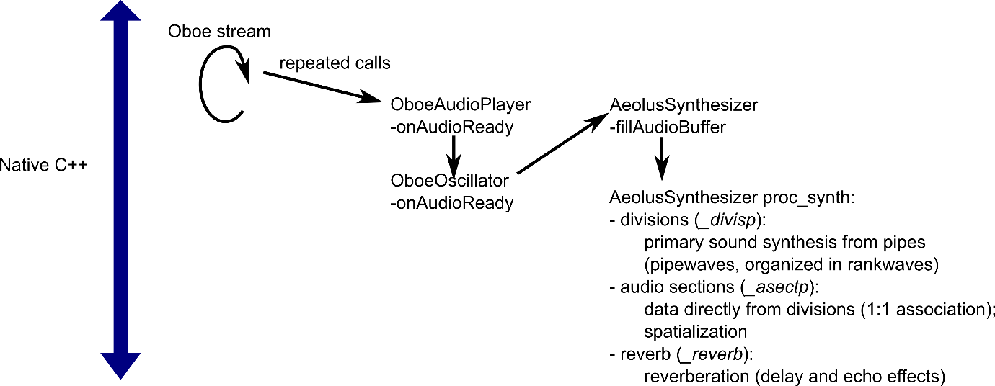
Figure 12. Audio synthesis
The audio data synthesis pattern of the Aeolus Android app follows the high-priority callback method outlined at:
https://chromium.googlesource.com/external/github.com/google/oboe/+/refs/heads/1.1-stable/docs/FullGuide.md#optimizing-performance:
Oboe is configured to run as a high-priority thread with the OboeAudioPlayer class serving as the primary callback, invoking onAudioReady. As outlined in the guide document, the audio data requests are transmitted to an oscillator, here implemented by the AeolusOscillator class (method call to AeolusOscillator::onAudioReady). The AeolusOscillator finally invokes the fillAudioBuffer on the AeolusSynthesizer class, which is the main synthesizer object of the native Aeolus implementation.
Overall, the regular repeated oboe data requests call therefore lead to repeated invocaton of AeolusSynthesizer::fillAudioBuffer. fillAudioBuffer is the central coordination routine for audio data synthesis, coordinating possible needs for output buffer allocation, message handling and audio data synthesis via proc_synth. The Aeolus sound signal synthesis process implemented in proc_synth is briefly outlined in Figure 12 and also discussed in more details in section “Aeolus sound synthesis”.

Aeolus Synthesizer Multi-threading
The native part of Aeolus is implemented as a multi-threading application. The main reason for doing so is separation of resource-intensive or blocking tasks from the high priority audio thread, such as to avoid audio glitches.

Inter-thread communication used by the native Aeolus implementation
To ensure coherent states of the various threads, asynchronous inter-thread communication is used by Aellus. Two distinct technologies are used for this purpose:
- The sophisticated ITC framework for inter-thread messaging based on the clthread library. This interthread communication provides for sophisticated messages, including exchange of pointers and objects and is mainly used for native Aeolus loading and reconfiguration aspects.
- For shorter, binary messages such as midi messages, binary queues are also used.

Inter-thread messaging
This project is based on the Aeolus Synthesizer implementation by Simulpiscator, available at https://github.com/SimulPiscator/aeolus, itself a fork from https://kokkinizita.linuxaudio.org/linuxaudio/aeolus/ . The original implementation by Simulpiscator is targeted at Desktop computers, namely Windows and Linux. The Aeolus Android project is a port to Android, the essential addition being an Android user and system interface; the core Aeolus functionality in terms of pipe wavetable-based audio synthesis is maintained. This includes the multi-threading architecture of the Aeolus Engine, which targets glitch-free Audio production by allocating time consuming and blocking activities to threads separate from the high-priority audio thread.

clthreads library
For high-level thread management, Aeolus uses the clthreads library. The clthreads library is available from https://github.com/dmeliza/clthreads , according to the author dmeliza because “the source was getting difficult to find elsewhere, and the library is needed for some really nice audio software”. The clthreads library leverages the basic pthread framework, which is an integral part of Google’s Bionic C standard library for Android, through the #include <pthread.h> directive in clthreads.h
The clthreads library adds an object-oriented implementation layer to the basic POSIX p-thread functionality offered by the pthread framework. In detail:
- clthread offers predefined object-oriented thread types
- P_thread: object-oriented wrapper for a basic P-thread: adds standardized start routine and thr_main as the thread’s default loop function.
- H_thread: P-thread capable of receiving inter-thread-communication messages (see below) with a simple input message queue. In the linux implementation of Aeolus at https://github.com/SimulPiscator/aeolus, a H-thread is used for reading the command line (i.e. Reader at https://github.com/SimulPiscator/aeolus/blob/master/source/tiface.h); as there is no linux command line interface to control the Aeolus app here, this functionality is disabled.
- A_thread: P-thread configurable for communication with multiple H- or A- threads by means of configurable output destinations and multiple input queues. In the Aeolus Android app, the main Aeolus native threads are A_threads. This concerns the Aeolus native control thread spawned from AeolusSynthesizer, the model thread from the Model class, the slave thread from the Slave class, and the native UI representation thread from the android_aeolus_user_interface class.
- clthread additionally defines an inter-thread-communication ITC framework. The framework is based on the exchange of ITC_messages, stored in queues for asynchronous handling by the threads. The Aeolus app extensively uses this framework for information exchange between the thread, and for this purpose defines its own series of ITC_messages (in messages.h).

Note: Audio synthesis and midi message handling occurs through threads controlled by Android different from the clthreads, see previous chapters.

The clthreads library is integrated into the present Aeolus Android implementation, with minor updates to address some compability and syntax issues.

libbthread library
The Bionic p-thread library lacks some of the functionality required by the clthreads library described above, namely a few specific thread cancelling functions. Fortunately, tux-mind has noticed this a while ago and was so kind as to provide the bthread library patching this issue. The libbthread library is available at https://github.com/tux-mind/libbthread and is incorporated into the present Aeolus Android app code, again with minor updates to fit into the Android architecture, to provide the necessary thread cancelling functions.

Inter-thread message flow
The messaging flow between the Aeolus app threads is by definition asynchronous, and in part event-driven rather than predefined, and is thus to some extent variable. Nevertheless, for understanding and harvesting the Aeolus inner workings, it is useful to establish general principles of inter-thread communication. The inter-thread communication scheme is particularly important during app startup.
Figure 13 shows the inter-thread messaging scheme during application startup, up to update of the user interface to reflect the Aeolus native configuration.
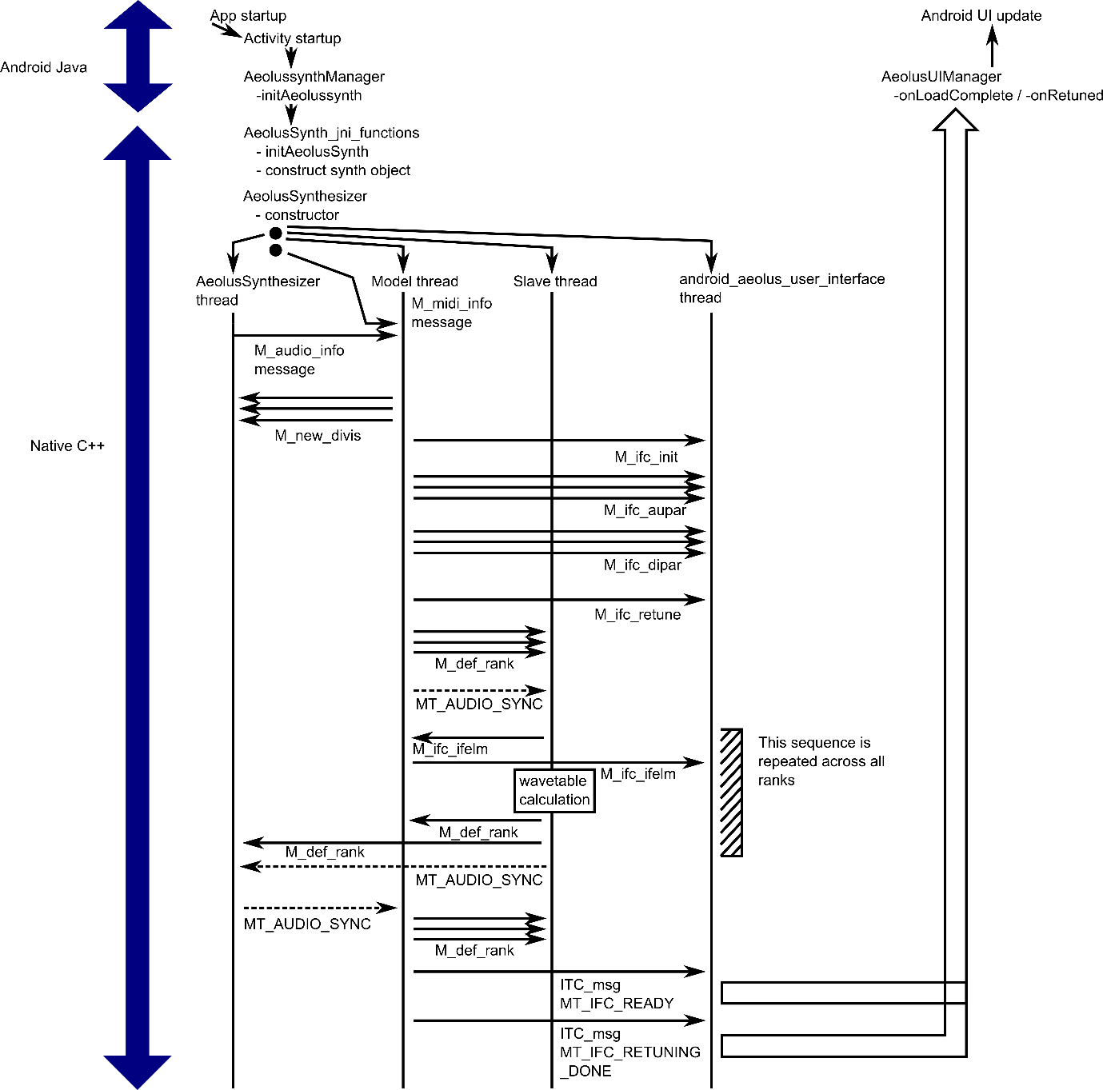
Figure 13. Interthread messaging. Solid lines represent ITC object messages, dashed lines represent ITC messages without object transmission.
Here are some details regarding the inter-thread messaging scheme outlined in Figure 13:
- The application starts in the Android Java part. The primary app startup activity is the Java class AeolusActivity.

- Among others, the AeolusActivity initiates loading of the native part through a call to AeolussynthManager.initAeolussynth. This is a jni function, mapping into AeolusSynth_jni_functions and instructing the native part to initialize the central synth object, which is an application-wide singleton of type AeolusSynthesizer.
- The constructor of the AeolusSynthesizer class orchestrates the launching of the Aeolus native threads. This includes the oboe audio thread, discussed separately (section Oboe audio output), and:
- the AeolusSynthesizer thread. The AeolusSynthesizer class inherits from A_thread (see section clthreads library) and the threading functionality is used to launch a specific AeolusSynthesizer thread. This thread orchestrates further application startup and reconfiguration events. It also ensures that the objects necessary for sound signal synthesis are usable during the callbacks from Android oboe audio thread, which queries AeolusSynthesizer for audio data synthesis (see section Oboe audio output).
- the Model thread. This thread is launched from the model object, which is a member of AeolusSynthesizer instantiated in the AeolusSynthesizer constructor. The model object is of class Model, which also inherits from A_thread. The role of the model thread is to handle the Aeolus configuration in terms of the various Aeolus elements and namely divisions and ranks (a rank being a group of pipes played together, generally with a recognizable, specific voicing).
- the Slave thread. Like the model thread, the slave thread is launched from a class member of AeolusSynthesizer, the slave field. The slave object is of class Slave, inheriting from A_thread, and is also launched as a thread during the AeolusSynthesizer constructor. The role of the slave is thread is execute time-intensive tasks, namely loading or calculating of the wavetables for synthesis.
- The android_aeolus_user_interface thread. Similarly to the other threads, it is launched from a class member field of AeolusSynthesizer (the _ui field of class android_aeolus_user_interface) inheriting of A_thread. The android_aeolus_user_interface thread represents the essential elements of the user interface and namely the state of the stops. Compared to the original linux/windows implementation, this thread is more limited since the graphical UI display and user event handling is taken care of by the Android Java part of the app; to ensure synchronization between the native and the Android Java representation of the UI, the android_aeolus_user_interface notifies the Java part when relevant changes occur on the native side.

- The launching of the AeolusSynthesizer, model, slave and ui thread triggers a cascade of thread communication events that permit to fully load the native Aeolus synthesizer engine. In detail:
- Upon thread startup, the AeolusSynthesizer transmits key information and pointers to key objects to the Model thread, by means of an ITC message of type M_audio_info. This informs the model about key audio parameters such as the sampling frequency, and via the pointers, permits it to update audio synthesis parameters as new information is received. The AeolusSynthesizer thread then goes on listening for messages from other threads (or possibly treat messages if already in the queue).
- Upon thread startup, the model thread reads the instrument definition from the instrument definition file and also loads the presets from the preset file. After this, it continues by listening for messages from other threads (or possibly treat messages if already in the queue).
- The slave and ui thread immediately start listening for messages from other threads after startup.
- After launch of the 4 threads, the AeolusSynthesizer constructor sends an M_midi_info to the model thread. The M_midi_info message conveys the address of the midi map along with some other information to the model. The midi map holds the mapping of the input midi channels to the keyboards of the Aeolus synthesizer, permitting to route specific midi input to specific audio output of the Aeolus synthesizer.
- The model thread considers that the Aeolus native implementation is ready for loading of the settings and wavetables as soon as it disposes of both the audio and midi information, that is, as soon as it has received both the M_audio_info and the M_midi_info message. To proceed with application loading, the model thread informs the AeolusSynthesizer thread about the divisions (information that the Model loads from the instrument definition file) via M_new_divis messages, one per division. This permits the AeolusSynthesizer thread to instantiate the divisions and apply division-level configuration.
- The model thread also informs the ui thread about the Aeolus application structure as loaded from the definition file. It does so via a series of ITC messages, namely: M_ifc_init to convey the overall structure in terms of user interface groups, keyboards, divisions, temperaments and in particular their labels and interface element numbers; M_ifc_aupar for global and group-wise audio parameters (volumes, reverb settings), M_ifc_dipar for division-wise parameters (tremulant parameters, swell parameters), and M_ifc_retune to indicate the impending retuning / reloading of the wave tables.
- Next, the model thread initiates loading or generation of the sound synthesis wavetables. These time-consuming operations are performed by the slave thread. To initiate rank loading, the model thread runs the divisions and posts a M_def_rank ITC message to the slave for every rank (=set of similarly voiced pipes) to be loaded. After this set of messages, the model thread posts a final MT_AUDIO_SYNC message and continues by listening for further incoming messages.
- Meanwhile, the slave thread starts to go through the queue of M_def_rank messages received from the model thread in the previous step. For every such message, the slave either loads the wavetables for the pipes in the rank or recalculates them. (Re-)calculation takes place when no pre-calculated .ae1 files are available, or when the tuning or base frequency of the stored .ae1 files do not match the present tuning and base frequency, otherwise, loading is preferred as it is much faster. To permit possible readjustments during retuning, for each element being retuned, the slave thread notifies the model via a M_ifc_elm message (of type MT_IFC_ELATT). The model relays this also to the ui thread, for possible adjustments. In the present Aeolus Android implementation, this information is not used specifically. Having notified the model of the impending retuning, the slave threads proceed with loading or recalculation of the ranks wavetables (that is, one wavetable for each pipe in the rank). Once the wavetable calculation completed, the slave completes the M_def_rank message with the newly calculated wavetable and sends it back to the model and AeolusSynthesizer thread. The model and AeolusSynthesizer threads in turn update the ranks in their divisions correspondingly.
- When the slave thread reaches the end of the M_def_rank messages in its queue, it will find the MT_AUDIO_SYNC message in the queue. To indicate that rank loading has completed, it sends an MT_AUDIO_SYNC message to the AeolusSynthesizer thread, which echoes it also to the model thread.
- Upon reception of the MT_AUDIO_SYNC message, the model knows that wavetable loading is complete. The model proceeds with instructing the slave to save the wavetables as .ae1 file, using M_def_rank messages, of ITC message type MT_SAVE_RANK. File saving will from here on occur in the background by the slave thread. The model also notifies the ui thread that Aeolus is ready for sound synthesis via a MT_IFC_READY message, and a MT_IFC_RETUNING_DONE message to indicate that a possible new tuning / base frequency readjustment is done. With the messages, the Aeolus native loading completes.

- Upon reception of the MT_IFC_READY / MT_IFC_RETUNING_DONE message, the ui thread notifies the Android Java part of the application to indicate that Aeolus is ready for sound synthesis, by a jni callback chain through AndroidAeolusUserInterfaceOnLoadComplete / AndroidAeolusUserInterfaceonRetuned (static functions in android_aeolus_user_interface.cpp), invoking AeolusUIManager.onLoadComplete respectively AeolusUIManager.onRetuned on the Android Java side. This scheme follows the general approach detailed in section “From Aeolus C++ to Android Java”. Following these calls, the Android Java interface is updated by means of series of Java->C jni calls to query the state of the different elements as described generally in section “From Android Java to Aeolus C++”.

Inter-thread binary queueing

Queues
The binary interthread communications queues are set up as static objects in AeolusSynth_jni_functions.cpp.
They serve as one-way communications between the AeolusSynthesizer, Model and Imidi classes, that is, to be more precise, the synth, synth.model, synth._midiInterface objects that instanstiate these classes.

Object | Structure | AeolusSynthesizer | Model | Imidi
note_queue  (_qnote pointer in classes) | 32-bit queue, for playable midi notes | Read operation (common 32-byte message processing via proc_queue) | - | Write operations to queue incoming midi notes to play by  AeolusSynthesizer thread
comm_queue  (_qcomm pointer in classes) | 32-bit queue for Aeolus synthesizer state updates | Read operation  (common 32-byte message processing via proc_queue) | Write operations to signal stop activation / dynamic division parameters | -
midi_queue  (_qmidi pointer in classes) | 8-bit queue, but used in 3-byte groups for 3-byte midi messages | - | Read operations to handle special midi commands | Write operations to queue special midi commands other than notes
Table 1 Inter-thread binary communication queues

Encoding format

32-bit queues: _qnote and _qcomm
The two 32-bit queus hold 4-byte binary messages, and share a common encoding scheme.
The encoding of the bytes is as follows:
Byte | Encoding
0 (least significant) | Holds the keyboard activation and hold bits.  -The lower (least significant) 6 bits are the keyboard bits  0x..100101 means that the note concerns keyboard 1, 3 and 6 (e.g. bits 1,3 and 6, starting from the least significant bit; there is a maximum of 6 possible keyboards although typically only 4 are used)  This is generally derived from the midimap, which indicates the channel to keyboard mapping.  -The seventh bit is carried over from indication of holding on a keyboard byte, but generally the hold information is conveyed in the _qnote queue by the third byte.  -The eight bit was at one point of time of Aeolus part of an addressing system for divisions but seems unused at present
1 ( i.e. 8 bit shift) | Midi note code – 36, notes lower than 36 are not played by Aeolus.
2 ( i.e. 16 bit shift) | Hold mask (bit-wise as for keyboards)
3 ( i.e. 24 bit shift) | General command bit, partially known to authors of this document: least significant bit 1 for on, 0 for off. 4th bit for setting division parameters. When this is on, the division index is in byte 2, the parameter index in byte 1, and the value follows in the next 32-bit message.

Table 2 Format of the 32-bit queues

8-bit queue: _qmidi
_qmidi is a single byte queue; it is used here to deposit midi command messages in a 3-byte format by each time using three consecutive bytes. The allocation of the bytes is as follows:
Byte | Encoding
0 | Command byte.  0x90 = select preset via special note command (i.e. this is a program change within the already selected bank)  0xB0 = division level parameters, or bank select. In this case, the lower 4-bits are the channel, i.e. 0xBc, c is the channel  0xC0 = program change within bank
1 | Value 1.  For byte 0 = 0x90, the preset + 24 (i.e. midi notes 24-33 are used to access the first 10 presets)  For byte 0=0xB(c), code for the division parameter or bank select (MIDICTL_SWELL, MIDICTL_TFREQ, MIDICTL_TMODD, MIDICTL_BANK, MIDICTL_IFELM, for values see global.h)  For byte 0=0xC0, the preset within the current bank to be selected
2 | Value 2. For byte 0 = 0x90, ignored. For byte 0=0xB(c), the value to set for the division parameter or the bank. For 0xC0=ignored.

Table 3 Format of the 8-bit queue

Aeolus sound synthesis

Principles of sound synthesis in Aeolus
Aeolus is fundamentally a wavetable sound synthesizer. This means that pre-calculated sound amplitude data is read from tables loaded into memory to generate the sound amplitude data over time. Wavetables are pre-generated and held in memory for reasons of speed, with present computing power available under typical Android tablet devices appropriate for this app, fully real-time sound synthesis is not feasible (yet).
This being said, Aeolus is also an additive synthesizer in that sound amplitude from different pipes is additively superimposed. After this primary synthesis, secondary effects such as tremulation, reverberation, and volume adjustment are carried out, before final spatialization depending on the output configuration.
Note: Aeolus is wavetable synthesizer and not a physical organ model. Physical processes of sound generation are emulated in rather profound detail through harmonic synthesis, but not directly. This means that pipe-pipe interactions are limited to additive synthesis, phase locking and other cross-pipe coupling effects will not be taken into account.

Wavetable loading

Model object hierarchy
In Aeolus, instrument initialization is conceptually and methodologically separated from instrument usage.
The loading and configuration part is carried out be the Model.
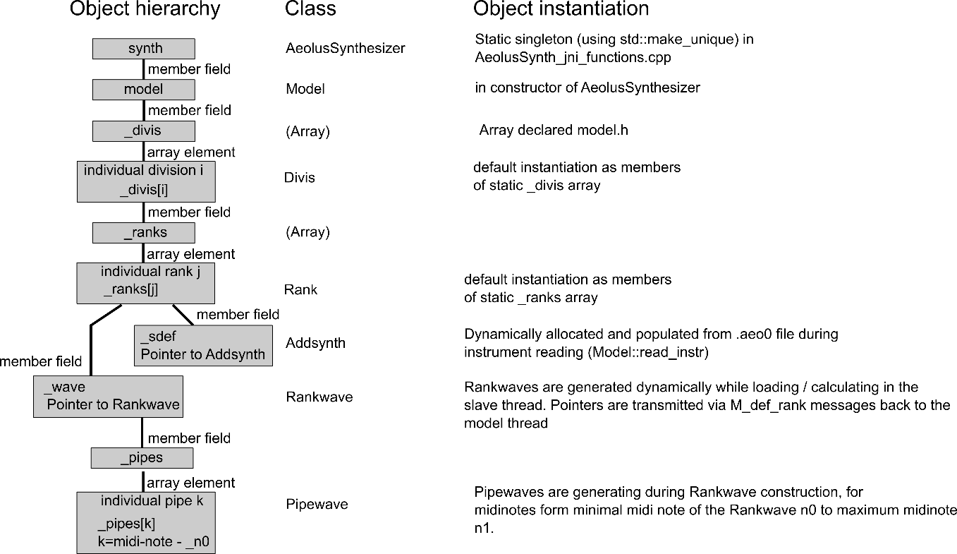
Figure 14. Object hierarchy for sound synthesis in the model thread
Figure 14 shows the hierarchy of the principal objects during Aeolus instrument loading:
- The synth object is the global singleton responsible for accessing and orchestrating Aeolus
- Its class member model is responsible for orchestrating the loading of the native part.
- The model holds a limited representation of the divisions, in the form of an array of Divis objects. Note: The Divis class is distinct from the full Division class, used during sound synthesis by the AeolusSynthesizer thread (c.f. section “Audio data synthesis”).
- Each Divis object holds an array of Rank objects
- The Rank object associates a pointer to a Rankwave, and a pointer to an Addsynth. The collaboration between Rankwave and Addsynth is at the heart of Aeolus wavetable generation: The Addsynth object contains the parameters for wavetable generation, the Rankwave provides the machinery for wavetable synthesis and storage.
- For handling the wavetables of the individual pipes (having different pitch), the Rankwave object contains an array of Pipewaves. Each Pipewave corresponds to a single organ pipe with a defined pitch; by sharing the Addsynth for configuration at the level of the Rank objects, similar voicing of the the pipes of a Rank is ensured.

Pipe voicing through Addsynth
The Addsynth configuration objects are used loaded by the model from the .ae0 files (known as “stop” files). They are transmitted to the slave thread via M_def_rank messages (cf. Section “Inter-thread message flow”) and used by the slave thread to configure wavetable synthesis by the Rankwave. For this, the Rankwave::gen_waves and Pipewave::genwave wavetable generation method take an Addsynth pointer as an argument.
Addsynth provides three types of configuration settings: rank-level parameters common to all pipes of a rank, note-dependent values with interpolation of (slightly) note dependent values across the midi scale, and parameters values for individual harmonics, also note-dependent across the midi range.
Type of configuration setting | Listing | Comment
Single value | Text values: .ae0 file name, name of rank, and other values  Numerical values: n0 first midinote, n1 last midinote of the rank, frequency multipliers for voicing, reverb delay, spatialization information | These values are rank-level configurations and apply to the rank as a whole. These values are stored as simple class members of Addsynth objects.
Note-dependent values | Possibly frequency-dependent pipe attributes: volume, random and fixed frequency offset, instability, attack and release characteristics | These values are configured as potentially midi note dependent, with interpolation to cover the entire note range with a few support points. N_func objects are used to represent and calculate these values.
Note-and-harmonic dependent | Values that are not only dependent on frequency but differently so for different harmonics: harmonic amplitude (given the possibility of smoothly adjust composition across the midi notes); random amplitude variation per harmonic, attack characteristics per harmonic | These values are stored and produced by HN_func objects – which are essentially a collection of N_func objects representing the set values for the different harmonics.
Table 4. Addsynth parameters
The N_func class provides for linear interpolation of parameter values across the midi note range (i.e. across the pipes of rank), with a minimum of 1 support point (constant value) and a maximum of 11 support point across the midi range. HN_func is a collection of N_func’s across a maximum of 64 individual harmonics.

Generation of wavetables
Wavetables are generated in the slave thread. Note that to accelerate Aeolus app loading, wavetables are loaded from .ae1 storage files whenever possible, and re-synthesized only at either first startup or change of tuning settings.
In a given tuning, the configuration settings contained in the Addsynth parameter object are sufficient to determine the wavetable generation.

In-memory storage of the wavetables
The wavetables are stored as part of the Pipewave objects, each of which represents a given pipe of the organ. More precisely, the wavetable of a Pipewave object is a float array of length k starting from float point _p0, and both k and _p0 are member fields of the Pipewave object. Allocation is dynamic, with deletion and re-allocation upon retuning. The wavetable of given pipe is a consecutive linear float array, conceptually divided into three contiguous sections:
- Attack section (of length _l0, starting point _p0): Duration based on the maximum attack time across all harmonics, rounded to complete periods
- Loop section (of length _l1, starting point _p1): Calculated using looplen() to ensure proper looping without clicks
- Tail section, starting point _p2: Extra samples copied from the loop start for smooth transitions. Length k-_l0-_l1.
The wavetable buffer length k is calculated as follows:
- The attack loop length _l0 is calculated from the pre-configured attack duration (which is provided by the Rankwave’s Addsynth, which is passed as a parameter to the Pipewave’s genwave function when generating the wavetable) and the common sampling frequency
- The main loop section length _l1 is determined by the Pipewave::looplen function. The idea is to avoid phase jumps and so _l1 is found as a number of samples that taking into account the sampling frequency, optimally corresponds to an integer number of cycles at the pipe’s base frequency. Technically, the algorithm of the looplen function is a variant of Euclidian division algorithm to obtain an integer number of cycles at pipe base frequency fitting optimally with the sampling frequency. See documentation of the looplen method in rankwave.h for further details.
- The buffer length k is finally determined by _l0+_l1 plus a number of per-audio-period samples (PERIOD) + a bit of extra to permit for handling of the tail.

Wavetable calculation
The wavetables are calculated pipe-wise, via Pipewave::genwave, invoked through the rank-level Rankwave::gen_waves method.
The wavetable calculation is ultimately based on evaluation and arithmetic addition of sinusoidal harmonics, with various aspects of attack, loop and release parts configured through the Addsynth. The details are probably best understood from the commented source code in Pipewave::genwave.

Wavetable use for Audio synthesis

AeolusSynthesizer division-rank-pipe object hierarchy
Once the loading steps for divisions, ranks and pipes completed by the model and slave thread, ITC messaging is used to transmit the necessary information to the AeolusSynthesizer thread (see section “Inter-thread message flow”).
From the messages received, the AeolusSynthesizer class constructs its own list of divisions (using Division objects referenced by pointers), and imports the hierarchy of Rankwaves and Pipewaves generated by the slave thread (via reception of M_def_rank messages). The resulting object hierarchy is shown in Figure 15.
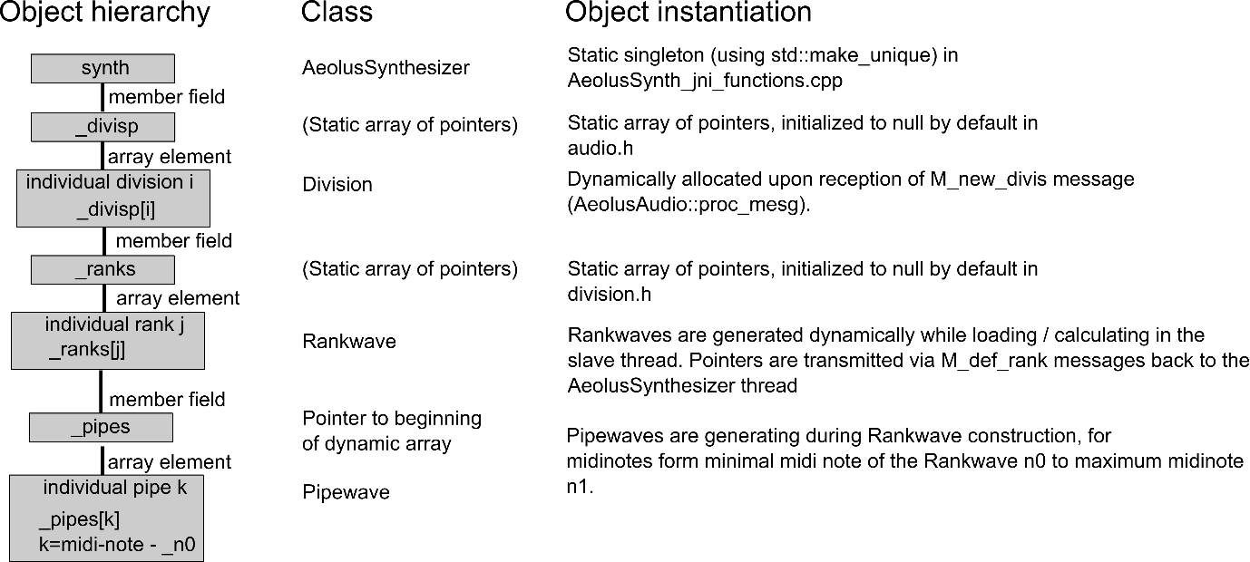
Figure 15. Object hierarchy for sound synthesis via ranks in the AeolusSynthesizer
Comparing the object hierarchy used by the model thread for loading (Figure 14) with the object hierarchy prepared by the AeolusSynthesizer thread (Figure 15), one notices two important differences:
- First, the Model thread uses the Divis class to represent the divisions, while the AeolusSynthesizer class uses the Division class. Both Divis and Division represent the divisions of the Android Aeolus app, but the focus is different: the Divis class is a minimalistic container with essentially the administrative function of regrouping the ranks; the Division class also regroups the ranks, but adds audio-level functionality such as the division-level tremulant and swell elements, and provides the machinery for actual sound synthesis.
- Also, the “Rank” and “Addsynth” objects are not transmitted to the AeolusSynthesizer. This is because once the wavetables are generated, the parameters of the Addsynth are not needed anymore, and it is enough for the AeolusSynthesizer to be aware of the Rankwaves directly.

Sound signal synthesis
The Aeolus Android app uses Oboe for driving sound output, and the basic principles of oboe usage are outlined in section “Audio data synthesis”.
Briefly, through a cascade of function calls initiated by the recurrent audio request calls from oboe, the proc_synth function of the AeolusSynthesizer synth object is invoked.
This in turn invokes the Division::process functions on the divisions. Each division invokes the play function of its ranks. In terms of output buffers, the divisions provide an intermediate output buffer (_buff field) of which the ranks are aware as they receive a pointer to _buff through the invocation of the Rankwave::set_param function upon integration of the Rankwave into the divisions. Each Rankwave, or more precisely each currently active Pipewave within the Rankwave can therefore autonomously modify the output buffer _buff with its own sound signal. They do so by appropriately moving through their wavetables and adding their signal to the values already in the output buffer. Once the Rankwave processing completed, still within Division::process, the audio data is transmitted to the audio section associated with the division.
Following this, the audio data is processed by the audio sections for spatialization, adjusted for reverb effects and ultimately used to provide the audio data to oboe by copying over the final values into the oboe buffer, as outlined in section “Audio data synthesis”.

Aeolus configuration files

definition file: Aeolus instrument configuration

Content
The general configuration of the Aeolus synthesizer is created during startup by using the instrument definition file. This is carried out in the model thread, more precisely in the Model::read_instr member function. The underlying “definition” file is human-readable, and defines:
- Tuning (frequency and tuning table)
- Keyboards
- Divisions with ranks (including specification of the .ae0 file to load for each rank
- User interface

File location
The “definition” file is part of a zip located at:
<project root>/app/src/main/res/raw/aeolus.zip
This zip file contains the “definition” and the “presets” file.

presets file: Preconfigured Aeolus user interface settings
The presets file contains, in binary form, user interface settings that can be applied to the Aeolus user interface. By default, the first preset is used for setting the initial state of the user interface.

File location
The file “presets” is part of the zip file “aeolus.zip”, located at <project root>/app/src/main/res/raw/aeolus.zip in the Aeolus source code.
This zip file contains the “definition” and the “presets” file.

Overall file structure
The preset file has three parts:
- The first 16 bytes are the file header bytes (i.e. offsets 0x0-0xF). This also includes the actual number of groups of elements in the user interface (ngroup).
- The next 256 bytes define 8 midi routing presets (i.e. offsets 0x10 to offset 0x10F. Each midi routing preset consists of 16 entries, each entry being made of up of 2 consecutive bytes.
- The last part of the file is optional, and of variable length (offset 0x110 and beyond). If present, it consists of blocks of 4 x (1+ngroup) bytes, each block coding for a user-defined preset for setting the activation state of the on/off user interface elements. Each preset consists of 4 header bytes, used to define preset bank index and program index, and a 32-bit = 4byte binary mask for each user element group. In the default preset file presented here, there are no user element presets defined and so the third block is absent.
For multibyte integers, the file is little-endian, that is, the least significant bits have the lowest offset address.

File header bytes
Figure 16. Preset file header

Text header
As shown in Figure 14, the preset file starts with the 0-terminated character chain “PRESET”.

Number of user interface groups
Figure 17. Number of user interface groups
Within the header bytes, the two bytes at offset 0xE and 0xF, shown in Figure 15, define the number of user interface elements ngroup. The integer is a 2-byte integer, and the little-endian format means that the least significant byte has the lowest offset address int the file. In the present file, ngroup=0x0004=4.

Midi routing presets

Midi routing preset 0

Preset 0, mapping of midi channel 0
Figure 18. Midi mapping instructions, mid routing preset 0, channel 0
The mapping in preset 0 for midi channel 0 is derived from the two bytes shown in Figure 16, at offset 0x10 and 0x11. Again, the encoding is little-endian, that is the hexadecimal value of the 2-byte unsigned integer is 0x5002. As outlined in section “Loading of the midimap”, the 0x1000 bit indicates usage of the midi channel 0 for keyboard routing. The 0x1000 bit is true since 5 is 0b101 in binary. Therefore, also as outlined in section “Loading of the midimap”, the 0x000K bits are used for indexing the keyboards; this means that midi channel 0 will be mapped to keyboard 2. Since both the keyboard and midi channel indexing is 0-based, at the user level this means that the 1st midi channel is mapped to keyboard #3. Keyboard #3 happens to be labelled “I”, and so the mapping encoded by the two bytes is that the 1st midichannel is mapped to keyboard “I”. This corresponds to the default midi mapping shown in Figure 5. Note that in the default Aeolus Android configuration, divisions and keyboards are associated 1:1.

Preset 0, mapping of midi channel 1
Figure 19. Midi mapping instructions, preset 0, channel 1
The mapping in preset 0 for midi channel 1 is encoded in the same way as for midi channel 0. Briefly, the hexadecimal value is 0x3101, indicating active keyboard mapping, in fact of midi channel 1 to keyboard 1. Translated to 1-based user interface values, this means that midi channel 2 is assigned to the 2nd keyboard, labelled “II” in Figure 5.

Preset 0, mapping of midi channel 2 and 3
Figure 20. Midi mapping instructions, preset 0, channel 2 and 3
The two subsequent bytes are for midi channel 2 and 3 (zero-based indexing), similarly leading to the channel-to-keyboard mapping shown in Figure 5.

Preset 0, mapping of midi channel 4
Figure 21. Midi mapping instructions, preset 0, channel 4
The mapping of midi channel 4 corresponds to the special case of omni-keyboard assignment outlined in Loading of the midimap. Indeed, the lowest three bits are set to 1 (hexadecimal value 0x1007) and so channel 4 is mapped to all keyboards simultaneously. Taking into account 1-based user interface indexing, this corresponds to the selection of all keyboards / divisions for midi channel 5 shown in Figure 5.

Preset 0, mapping of midi channel 5-15
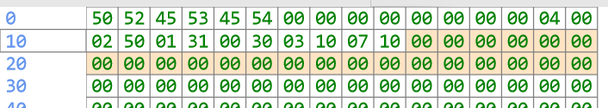
Figure 22. Midi mapping instructions, preset 0, channel 5-15
Channels 5-15 (6 to 16 for 1-based indexing) are not associated with keyboards / division (c.f. Figure 5).

Midi routing presets 1-7
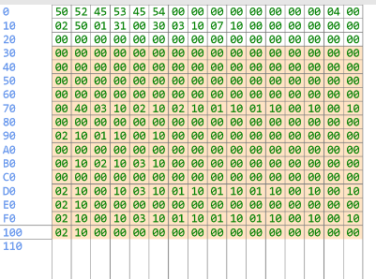
Figure 23. Bytes corresponding to preset 1-7
The bytes corresponding to preset 1-7 are shown in Figure 20 and are encoded similarly to preset 0. In the present implementation, these bytes are read but not applied, but could readily be used to allow for re-loading and saving of midi routing presets.

Optional user interface presets
In the default Aeolus preset file used here, there are no user interface presets defined.

Aeolus .ae0 “stop” files
The .ae0 files define each rank’s synthesis parameters. More precisely, the .ae0 files are read during instrument loading (Model::read_instr), during which the .ae0 parameters are used to populate each rank’s Addsynth parameter object via Addsynth::load.

File location
The .ae0 files are contained in a zip file, at:
<project root>/app/src/main/res/raw/stops.zip

File format

Little-endian byte order
The file format is binary with sections as defined below. Generally, the file is little-endian. The little-endian format is general and well defined. As a reminder, endianness pertains to byte-order and little-endian means that the least significant byte comes first (has the lowest offset), followed by increasingly significant bytes. Endianness is independent on the bit-order within each byte. Indeed, regardless of endianness, within each byte, the first bit (at the lowest offset) is the most significant.

Float values
Float values are read as single precision (4-byte), and follow standard encoding (IEE 754 format). The byte order is little-endian.

Header section (32 bytes)
This part identifies basic numeric information about the rank. Note, in the context of the user interface, ranks are also referred to as stops. This is slightly imprecise: although ranks are typically displayed as stops in Aeolus, there are also stops that are not ranks, but mixtures of ranks.
Offset | Size | Field | Description
0x0 |  | Magic | “AEOLUS” string identifier, null terminated
0x7 | 1 | Version | File format version, at present 0x02
0x8 | 18 | Padding | Null bytes (0x00)
0x1A | 1 | Number of harmonics | In this implementation, needs to be 0x40=64_{dec}. The default value for 0x00 would be 48dec but this is not compatible
0x1C | 1 | n0 | The lowest midinote in this rank
0x1D | 1 | n1 | The highest midinote in this rank
0x1E | 1 | fn | Frequency numerator
0x1F | 1 | fd | Frequency denominator
Table 5. .ae0 file header. Table in part generated by claude.ai upon prompted analysis of the source code of Addsynth::load.

Rank descriptor (160 bytes)
This part contains textual description of the rank.
Offset | Size | Field | Description
0x20 | 32 | Stop name | Stop name literal, null terminated, null-padded
0x40 | 56 | Copyright | Copyright information, string literal, null terminated, null-padded
0x78 | 8 | Mnemonic | Short stop name, string literal, null-terminated, null-padded
0x80 | 56 | Comments | User comments, string literal, null-terminated, null-padded
0xB8 | 8 | Reserved bytes | Reserved bytes
Table 6. .ae0 file text descriptor section. Table in part generated by claude.ai upon prompted analysis of the source code of Addsynth::load.

Note parameter value section (48 bytes per parameter, 8 parameters)

Structure of a per-note parameter section (48 bytes)
Each parameter section feeds into a N_func structure, which interpolates the values across 60 midi notes (from 36 to 96) with a maximum 11 support points spaced by 6 midi notes (e.g. half an octave). The interpolation works with a bit-mask: 1 in the bit-mask at position x indicates that the value is considered set and that the x-th value reported in the file should be used. A zero in the bit-mask in turn means that instead of using the value, interpolation should be done.
The structure of each N_func parameter block in the .ae0 file is:
Offset (relative within N_func block) | Size | Field | Description
0x00 | 4 | Bitmask | This 4-byte field is read into a int32 integer, with little-endian byte order. This means that the lowest byte at 0x00 offset is the least significant byte, at 0x01 the second least significant, at 0x02 the third least significant and 0x03 the most significant byte. After reading, the 11 least significant bits form the relevant bit mask. Every 1 value covers 6 midi-halftones, making the entire linear interpolation range equal to 60 values (10 interpolation ranges). Example: in bassoon.ae0, the first N_func block (for note volume) is at absolute offset 0xC0. The four bytes are 0x15, 0x00, 0x00, 0x00. The little-endian read-mode means that this is int32 = 0x00 00 00 15, or 0b10101. The bit-mask means that values at midi-halftones 36, 48 and 60 are set, the remainder interpolated respectively equal to the value at midi note 60 for the notes above 60.
0x04 | 44 | Values | These are 11 consecutive float values (with 4 bytes for every float). They represent the possible 11 values at interpolation points (36, 42, .., 96). Note that these values are taken into account as interpolation points only if there is a 1 in the corresponding bit mask position (see above).
Table 7. .ae0 substructure for each per-midi-note parameter. The offset is relative to the beginning of the block

Per-Note parameter listing
Sections as per Table 7 are defined at the following offsets, with parameter interpretation:
Offset | Size | Field | Description
0xC0 | 48 | n_vol | Per midi-note volume contribution (in dB)
0xF0 | 48 | n_off | Offset from tuning, in Hz
0x120 | 48 | n_ran | Random contribution to pipe frequency (applied during wavetable generation)
0x150 | 48 | n_ins | User comments, string literal, null-terminated, null-padded
0x180 | 48 | n_att | Maximum attack duration. The actual attack duration is more detailed and depends on the harmonic, this parameter is indicative for buffer length allocation.
0x1B0 | 48 | n_atd | Attack detuning. 0 means no detuning, 1200 is detuning by a factor of 2, the general dependency is 2^(x/1200). See definition of the detuned attack base frequency f0 in Pipewave::genwave for details.
0x1E0 | 48 | n_dct | Decay time during release when switching off the pipe
0x210 | 48 | n_dcd | Release detuning. 0 means no detuning, 1200 is detuning by a factor of 2, the general dependency is 2^(x/1200).
Table 8. Per midi-note parameter listing for .aeo files

Harmonic parameter value section (48 bytes per harmonic, 64 harmonics per rank, 4 parameters)

Structure of a harmonic parameter section
Each parameter section feeds into 64 N_func structures, each one representing a single harmonic’s values across the midi notes. As a reminder, each N_func section in the .ae0 file is 48 bytes and defined as explained in section “Structure of a per-note parameter section (48 bytes)”. Relative to the harmonics block, the offsets are:
Offset (relative within HN_func block) | Size | Field | Description
0x00 | 4 | Bitmask of 1st harmonic (fundamental) | Interpolation bitmask as defined in Table 5.
0x04 | 44 | Values for 1st harmonic | 11 consecutive float values (4 bytes each), used for interpolation depending on the bitmask (as in Table 5)
0x30 | 4 | Bitmask of 2nd harmonic (2x fundamental frequency) | Interpolation bitmask as defined in Table 5.
0x34 | 44 | Values for 2nd harmonic | 11 consecutive float values (4 bytes each), used for interpolation depending on the bitmask (as in Table 5)
0x60 | 4 | Bitmask of 3rd harmonic (3x fundamental frequency) | Interpolation bitmask as defined in Table 5.
0x64 | 44 | Values for 3rd harmonic | 11 consecutive float values (4 bytes each), used for interpolation depending on the bitmask (as in Table 5)
... | ... continued for further harmonics
0xBD0 | 4 | Bitmask of 64th harmonic (64x fundamental frequency) | Interpolation bitmask as defined in Table 5.
0xBD4 | 44 | Values for 64th harmonic | 11 consecutive float values (4 bytes each), used for interpolation depending on the bitmask (as in Table 5)
Table 9. .ae0 substructure for each per-harmonic parameter. The offset is relative to the beginning of the block

Per-Harmonics parameter listing
Sections as per Table 9 are defined at the following offsets, with parameter interpretation:
Offset | Size | Field | Description
0x240 | 3072 | h_lev | Level (intensity) of the harmonic contribution across the midi note spectrum. This is in logarithmic scale, 0 is unchanged from per midi note contribution, 6 is *2, -6 is *0.5, -12 is *0.25; the values are continues, examples for illustration.
0xE40 | 3072 | h_ran | Random variation of the harmonic volume, on the same logarithmic scale as h_lev.
0x1A40 | 3072 | h_att | Attack duration of the harmonic across the midinotes, in seconds
0x2640 | 3072 | h_atp | Attack parameter for the harmonic across the midi notes. The higher p, the shorter and marked the attack.
Table 10. Per harmonic parameter listing for .aeo files
The total file size for each .ae0 file is 12864 bytes. The documentation of the .ae0 file structure was generated in part by dialog interaction with claude.ai, in part by deeper review of the source code.

Installation of Aeolus configuration files

General principles
In Android applications, the installation of app-specific local data files is a subtle topic, due to the streamlining of application installation paired with restrictive user access rights.
Contrary to desktop operating systems such as Linux, Apple or Windows flavors, in Android, data files are not installed during the app install process, but later, during first launch. Correspondingly, the installation of the local “definition”, “presets” and also the various .ae0 files for the ranks is performed by Java code rather than by aspects of the installation process.

Implementation
The installation of the “definition”, “presets” and the .ae0 files is performed by the Java class AeolusFileInstallation, which is based on code provided at https://stackoverflow.com/questions/11734084/how-to-unzip-file-that-that-is-not-in-utf8-format-in-java.
In the common startup routine for the Java Android activities (specified in baseAeolusMidiActivity::initMidiAeolus), the native configuration files are set in place in two steps:
Step 1: The app’s proper storage folder is evaluated from the application context and shared with the C implementation. This is done via AeolusFileInstallation:: initStorageLocationsDefault, and jni transmission through AeolusFileInstallation::nativeSetStorageRoot.
Step 2: Creation of the “definition”, “presets” and the .ae0 in the proper subfolders of the app’s storage folder. For this step, AeolusFileInstallation examines the zip files containing the local data files (i.e. <project root>/app/src/main/res/raw/aeolus.zip and <project root>/app/src/main/res/raw/stops.zip; aeolus1.zip and aeolus2.zip are part of the original implementation and also installed, although they are not used). For each file contained in the zip, if the corresponding native counter part does not exist yet, AeolusFileInstallation::unzipinstallZipIfNotExists opens an ZipInputStream. This stream is read to exhaustion and the file is written to the Android’s permanent storage as the corresponding native file. In the process, the root access path is transmitted to the C-implementation, and through jni to the corresponding C function in AeolusSynth_jni_function.
The internal access paths after the installation are:
- <app private storage directory>/stops/Aeolus/definition for the instrument definition file,
- <app private storage directory>/stops/Aeolus/presets for the presets file
- <app private storage directory>/stops/stops/XYZ.ae0 for the .ae0 rank definition files, where XYZ is the name of the rank as configured in the definition file.
Note that the <app private storage directory> is not known in advance and may vary depending on the device, Android version and device configuration. It is however accessible at runtime in Java through mContext.getFilesDir().getAbsolutePath() where mContext is an appropriate context, for instance the application context accessible in the activities through getApplicationContext(). A further complication is that neither other users and nor simultaneously runnings apps (including Android Studio while debugging) have access to these files, and so to check whether the files exist during debugging, the application itself has to be used.

Special topics
The special topics section contains a highly technical discussion of some file and midi handling aspects, of interest only if implementation work in these areas is foreseen.

Midi channel mapping details
In Aeolus, incoming midi notes are routed according to their channel to ultimately activate (note-on events) or deactivate (note-off events) an associated set of pipes. This mapping happens via an intermediate channel-to-keyboard map, referred to as the midimap within Aeolus. The pipes then respond to the events on given keyboards. This ensures coherence between the division-level controls, which apply to the division’s keyboard(s), and midi channel-to-keyboard mapping.

Calling path including midi channel mapping
- The common entry point for an incoming midi note event in Aeolus is the noteon function of the synth singleton (of type AeolusSynthesizer). As detailed in section “Midi input handling”, the midi messages reach this function either through the native C (hardware midi) or Android Java and jni pathways (software midi).
- The noteon function stores the midi information in MidiEvent instance and invokes the proc_midi_event member of the synth’s Imidi instance. Namely, the MidiEvent’s note.channel field carries the midi channel information.
- In the Imidi::proc_midi_event the midi channel is translated to the keyboard mask. This happens by look-up in the _midimap variable (which itself is loaded from the preset, and in particular midi routing preset 0 at startup, for details section “Loading of the midimap”), which is an array associating each midi channel to a 2-byte integer. For the keyboard mapping, only the lowest 7-bits are of the 2-byte integers are used, and the lookup yields the binary mask indicating the necessary keyboards to be activated (1) or not (0). For regular midi notes to be synthesized by Aeolus, the note midi key is between 36 and 96, and proc_midi_function queues the note in _qnote according to the scheme outlined in Table 2. The lowest byte is used to transmit the keyboard activation state, 6 bits for the possible 6 keyboards and the 7th bit for holding the note or not.
- In the next loop of the oboe audio thread (AeolusAudio, in audio.cpp), e.g. in AeolusAudio::proc_queue this will be picked up as the thread will check on the queued note events. Identifying a midi note on event, the key_on (or key_off, if the note is to be de-activated; both functions defined in audio.h), is called. key_on sets the _keymap variable appropriately. The hold and 6 keyboard bits are set from the queue; the 8th bit is set to high to flag the _keymap entry for processing.
- This 8-bit high state will be specifically picked by the proc_keys1 procedure of the audio thread, which is run after proc_queue. proc_keys1 sets the 8th bit to low, and updates the divisions with the 7 remaining bit. That is, for each division, the Division::update function is called with the note information and the 7-bit information ultimately from stemming from the _midimap. The division then runs through its ranks. When there is an AND overlap between the _cmask of the rank and the midimap 7-bit terminus, the rank is turned on for the note at hand, otherwise it is turned off.

Setting of the ranks’ keyboard mask values
The setting of the _cmask values, which is a binary mask defining to which keyboard the ranks respond, is a relatively complex process. It is designed to permit for both variable configuration of the association between keyboards and divisions from the instrument definition file, and to permit dynamic update of this association.
- Upon initialization of the keyboards in Model::read_instr, the default mask of the k-th keyboard is 1 << k, with << being the binary shift operator, so this is a binary mask of the type 0b...000100 where the 1 is at the k-th position (zero-based, so here k=2). The keyboard mask is part of the _flags field of the keyboard variable
- Upon initialization of the divisions during instrument reading (also in Model::read_instr), the divisions are associated with keyboards. This allows for flexibility with the association between divisions and keyboards. The division mask is set to the corresponding 7 least significant bits of the corresponding keyboard _flags value. In the default Aeolus definition file, this means that the 4 divisions are associated with the division mask values 0b0000001, 0b0000010, 0b0000100 and 0b0001000.
- In the subsequent call to Model::init_audio, the division mask is transmitted as part of the M_new_division message to the AeolusSynthesizer thread.
- The AeolusSynthesizer thread copies the division mask to its own division list (i.e. the information is stored in _divsp[i]->_dmask, i indicating the i-th division). To do so, it uses set_div_mask, which also sets the _cmask values for all the ranks in the division to the division mask value.
- Subsequently, the ranks are loaded by the slave thread (see section “Inter-thread message flow”). At end of each rank loading, among others, an M_def_rank message is sent to the AeolusSynthesizer thread. Upon reception of the newly defined ranks via M_def_rank messages, the AeolusSynthesizer thread copies the _cmask currently configured to the _nmask field and sets the _cmask to 0.
- In the oboe audio thread, the AeolusSynthesizer::proc_keys2 method is invoked at every audio data request cycle. proc_keys2 is defined in audio.cpp and leads to a call to Division::update (unsigned char *keys) for each division. With the Division::update function, for each rank of the division, the _cmask is reset to the _nmask value (with corrective actions taken on the midi notes if there is a difference, to allow for the case where the rank masks are changed while playing).
Overall, this means that after the first oboe audio thread cycle following the reception of the M_def_rank message, the _cmask of each rank of the division is set to the correct bitmask for the keyboard.

Loading of the midimap

The midi map is a 16-member array of type uint 16, which is a two-byte or 16-bit mask, one mask for each channel. As outlined above, it indicates the mapping from the midi channel of incoming midi messages to the keyboards concerned by the messages. It is loaded as follows:
- The midi map is initialized upon construction of the synth object, which in the implementation here is the central AeolusSynthesizer object (i.e. the global synth object initialized in the AeolusSynth_jni_functions.cpp jni bridge).
- The midi map is the _midimap member of the AeolusSynthesizer object. It is defined and initialized to zero values by means of its declaration in audio.h.
- In the AeolusSynthesizer constructor, the address of the _midimap member is shared with the Imidi midi interface via a pointer passed to the constructor of IMidi. Similary, a pointer the _midimap is shared with the model member upon instantiation from the Model constructor.
- This sharing of pointers seems to happen in partial duplicate. Indeed, as outlined in section “Inter-thread message flow”, the midimap info is also shared through a M_midi_info. To be precise, IMidi sends this message during invocation of its open_midi member function, and the midi map address is transmitted via the _chbits member of M_midi_info. This means that in the end, the Model disposes of two copies of the pointer to the midimap, one as Model::_midimap and a second one as Model::_midi._chbits. They should both identically point to the primary midimap. The Model::_midimap pointer is available immediately upon object construction, while the Model::_midi._chbits pointer is correctly initialized only after reception of M_midi_info by Model, and so in general, the Model::midimap pointer is the appropriate pointer to use in the model class.
- During thread startup of the Model thread, the Model::read_presets method is invoked. This method reset the binary presets file describing stored pre-configured states of the Aeolus synthesizer. This file contains among others 8 pre-configured midimaps, with each midi map consisting of 16 values of 2 bytes each, as required. These 8 preconfigured midimaps are all loaded into the Model::_chconf array, with the i-th midimap stored in the Model::_chconf[i]._bits array.
- The bits from the first midimap, i.e. Model::_chconf[0]._bits are used to construct the new midi map entries. The assembly is non-trivial and aims at being able to re-use the keyboard masks (section “Setting of the ranks’ keyboard mask values” above). For every midichannel j in the Model::_chconf[0]._bits:
- The 0x1000 bit of Model::_chconf[0]._bits[j] is used to signal that the midi channel should be mapped to a keyboard at startup.
- Indeed, if the 0x1000 bit is 1, the keyboard index is taken to be the 0x000K bits, and the keyboard flags of the keyboard indexed by 0x000K are used for the least significant 7 bits (6 keyboard + hold bit) of the _midimap entry j. The higher 0xMM00 bits are copied to the _midimap[j]
- if on the contrary the 0x1000 bit of Model::_chconf[0]._bits[j] is 0, the midi channel j is considered inactive and the least significant bits of _midimap[j] are set to 0, which means that the midi channel will not activate any keyboard.
- As a special shortcut, if the last 3 bits of Model::_chconf[0]._bits[j] are 1, the last 7 bits of _midimap[j] are set to 1 so that the midi channel j is mapped to every possible keyboard and hold.
- Overall, after preset loading, the _midimap in Model (and thus also in AeolusSyntesizer and Imidi since they point to the same address) are set in such a way that the midi channels are mapped to the keyboards. In the default preset 0 in the presets file, the mapping is relatively simple: channel 0 is mapped to keyboard 0 (i.e. _midimap[0]=0x..01), channel 1 is mapped to keyboard 1 (i.e. _midimap[1]=0x..02), channel 2 is mapped to keyboard 2 (i.e. _midimap[2]=0x..04), channel 3 is mapped to keyboard 3 (i.e. _midimap[3]=0x..08), channel 4 is used to activate all possible keyboards (i.e. _midimap[4]=0x..7F), while all higher midi channels (5 to 15) are off (i.e. _midimap[5 to 15]=0x..00).

